Newsletter for the Members of the AMA Global Marketing Special Interest Group
Welcome to the May 2014 AMA Global Marketing SIG's monthly E-News.

In this AMA Global Marketing SIG newsletter, you will find:
Interesting Member Updates: Jan Napoleon Saykiewicz and Jan-Benedict E.M. Steenkamp
Vacancy
AMA Global Marketing SIG Conference 2014 - A Great Success
AMA Global Marketing SIG Award Invitations
Research & Teaching Support
- A Case Study by Jan- Benedict Steenkamp
- Journal Articles
Upcoming Conferences

Va

Board Members

Vice-Chair Membership,
Awards, Recognition
William Lundstrom
Cleveland State University
w.lundstrom@csuohio.edu

Chairperson

Frank Franzak
Virginia Commonwealth
University
fjfranza@vcu.edu

Chair-Elect
vacant

Vice Chair, Communication
Ruediger Kaufmann
Nicosia University
kaufmann.r@unic.ac.cy

Doctoral Student Liaison
Annie Cui Peng
West Virginia University
annie.cui@mail.wvu.edu
Caveat: New Design of E-News and Request for News
The AMA Global Marketing SIG is revamping its E-News to provide information ‘From Members to Members’. The intention is to share announcements of exciting developments, get to know each other better, and to promote more interaction and networking. We will be contacting you via email each month, asking you to provide us with interesting news about you and what is going on in your global life. Your reply can include:
- changes as to your job/affiliation
- awards you have received
- books published
- retirements
- notice that someone in our field has passed away
- etc.
Institution related news can include
- Innovative Programs you are working on
- Newly created Centers and/or Institutes
- Awards/Grants
- Symposium you are holding, guest visits
- Others…
E-News will also provide links to upcoming events, special issues, and recent publications that define our field. If you have content of this type, you can get it to Global Marketing SIG members by sending the web link to Rudi Kaufmann at Kaufmann.r@unic.ac.cy.

Conference Liaison
Michael R. Czinkota
Georgetown University
czinkotm@georgetown.edu

Conference Liaison
Constantine S. Katsikeas
Leeds University
buscsk@leeds.ac.uk

Conference Liaison
Camille P. Schuster
Cal State San Marcos
cpschuster@yahoo.com

Webmaster, Research Issues
Coordinator
David Griffith
Lehigh University
david.a.griffith@lehigh.edu

Treasurer
Vacant

Immediate Past Chair
Esra Genturck
Ozyegin University
Esra.Gencturk@ozyegin.edu.tr

Interesting Member Updates

Jan N. Saykiewicz
After 52 years, of teaching , researching, educating, and service, Jan N. Saykiewicz, of the Palumbo/Donahue School of Business, at Duquesne University, has retired. Jan divided his academic career between Europe (25 years) and the USA (27 years). Along the way, he was a Visiting Professor in China and Italy, and visited to give lectures on all continents. Memorable stops along the way were in Moscow, Russia and Paramaribo, Surinam. He is the Honorary Consul of the Republic of Poland. Remarkably, Jan did not miss a single day at work over those 25 years!!!
Professor Saykiewicz counts Peter Drucker, Jim Collins, Philip Kotler , and Michael Czinkota as major influences on his career as an international marketing educator. His official title is now Professor Emeritus. We wish Jan well as he strives to catch up on his naps.

Jan-Benedict E.M. Steenkamp
Jan-Benedict E.M. Steenkamp (“JB”) is C. Knox Massey Distinguished Professor of Marketing and Marketing Area Chair at the Kenan-Flagler Business School, UNC-Chapel Hill. Last week, Professor Steenkamp received the Louis W. Stern for the paper “Customer Loyalty to Whom? Managing the Benefits and Risks of Salesperson-Owned Loyalty” (published in 2007 in the Journal of Marketing Research). His most recent book is Brand Breakout: How Emerging Market Brands Will Go Global, published in 2013 by Palgrave Macmillan with a special Chinese edition published by CEIBS Publishing House.

Vacancy

Dan Laufer, from Victoria University of Wellington, will be traveling to AMA to interview people for a senior level Associate Professor of Marketing position (with tenure). Information about the position is available at: http://vacancies.vuw.ac.nz/positiondetail.asp?p=7015

AMA Global Marketing SIG Conference 2014 - A Great Success

The recently concluded 2014 American Marketing Association Special Interest Group conference on the Honorable Merchant and International Marketing was a great success! We had an excellent turnout of 30 participants representing nearly every continent at the Dreams Resort and Spa hotel in Cancun, Mexico. The 2014 conference was held from Wednesday, April 16th to Saturday, April 19th. The diversity of international participants cultivated unique research topics on the area of the Honorable Merchant and allowed for stimulating discussion to ensue. Research papers ranged from comparing Marketers to the Devil to cheating at Universities and Honorable practices for sustainable cocoa supply. The participants completed three rounds of Delphi Questionnaires on a wide range of topics. The results will be published later this year.

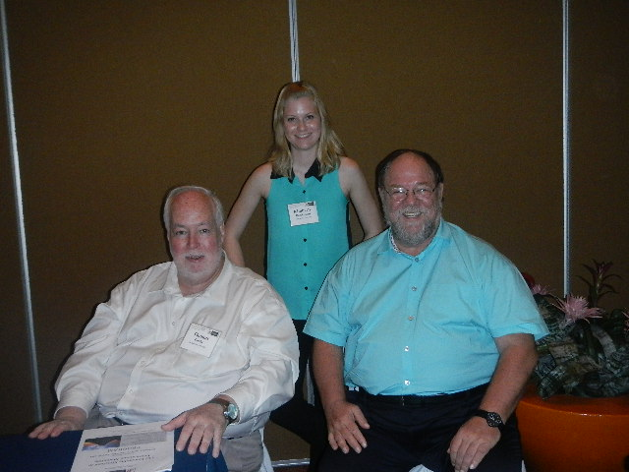
The main organization team: Michael Czinkota, Thomas Cook and Kimberly Boeckmann
For more information (including pictures), please, go to: http://michaelczinkota.com/2014/04/ama-sig-honorable-merchant-conference-2014-a-great-success/
AMA Global Marketing SIG Award Invitations

AWARD NOMINATIONS
The Global Marketing Special Interest Group of the American Marketing Association invites nominations (including self nominations) for the following two Annual Awards. Nominations for either award can be sent to William J. Lundstrom, Cleveland State University, (w.lundstrom@csuohio.edu) by June 6, 2014. Award recipients are expected to attend the 2014 Summer Educators’ Conference in San Francisco to receive their award.

SIGNIFICANT CONTRIBUTIONS TO GLOBAL MARKETING AWARD
This eminent award recognizes a distinguished educator for a lifetime of significant contributions to the field of global marketing. A key criterion is the achievement of a record that has influenced the advancement of global marketing knowledge. The Significant Contributions to Global Marketing Award will be presented at the AMA Summer Educators’ Conference in San Francisco, on Saturday, August 2, 2014.
2013 EXCELLENCE IN GLOBAL MARKETING RESEARCH AWARD
This distinguished award recognizes the author(s) of an outstanding research article, published within the last 10 years, which has significantly influenced the direction of global marketing. The Excellence in Global Marketing Research Award will be presented at the Summer AMA Educators’ Conference in San Francisco, on Saturday, August 2, 2014.

Research & Teaching Support (Case Study and Articles)

TCL’s Global Expansion through Mergers and Acquisition: What Went Wrong?
Case Centre Reference no. 314-087-1
Authors: Jan-Benedict E.M. Steenkamp; UNC Kenan-Flagler Business School
http://www.thecasecentre.org/educators/products/view?id=116892The case describes the transformation of TCL from a humble manufacturer of magnetic tapes to one of the largest Chinese consumer electronics firms, with global sales of US$11.3 billion and a market presence around the world. Unlike many other Chinese firms like Huawei or Haier which grew organically, TCL relied heavily on mergers and acquisitions (M&A) as strategy to enter other countries. Yet, these M&A almost invariably failed to deliver on their high promise, due to limited understanding of foreign markets, conflicting goals of joint venture (JV) partners, and cultural differences. The case ends in 2013 with the company being at a critical juncture. The case raises a broad set of issues related to the evaluation and effectiveness of international expansion and brand building through M&A – areas of critical importance in today’s global business environment.
This case is suitable for a Global Marketing course, Global Strategy course, and Brand Management course and is available through The Case Centre (formerly ECCH).

The following articles published in the Journal of International Marketing might be useful to be used in your lecture:

http://journals.ama.org/doi/abs/10.1509/jim.13.0075
http://journals.ama.org/doi/abs/10.1509/jim.13.0079
http://journals.ama.org/doi/abs/10.1509/jim.13.0129
http://journals.ama.org/doi/abs/10.1509/jim.13.0158

Upcoming Conferences and Calls for Special Issues

Upcoming Conferences:
https://www.ama.org/events-training/Conferences/Pages/AMA-2014-Summer-Marketing-Educators-Conference.aspx
The Global Marketing SIG is hosting the DocSIG for a reception at the Educators' Conference in San Francisco. This will be on Saturday evening, August 2, location to be announced.
http://anzmac.org/conference
Calls for Special Issues:
http://www.journals.elsevier.com/international-journal-of-research-in-marketing/call-for-papers/call-for-papers-branding-in-a-digitally-empowering-world/
http://www.emeraldgrouppublishing.com/authors/writing/calls.htm?id=4853
AMA GLOBAL MARKETING SIG WEBSITE
The Global Marketing SIG website is now available at: AMAGLOBALSIG.ORG

Please, contact: Rudi Kaufmann
Kaufmann.r@unic.ac.cy
Tel: 00357- 22841643
Skype: Kaufmann2307

Global Marketing Like Never Before

